**Lab 1.1**

Sơ đồ class:

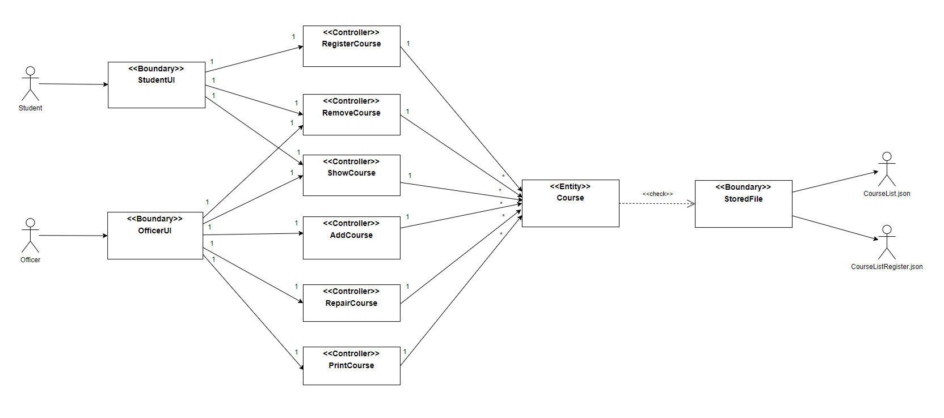

Sequence Diagram:

